Patrice Moracchini
CSD310-308A(2261-DD)
Nov 15, 2025

MySQL Functions
Module 5.2 Assignment
Pr. Sampson

I selected three functions out of MySQL Functions :
- LOCATE()
It allows us to find the position of a string within a substring
Its syntax is the following: LOCATE(substring, string, start)
The substring is what we look for; the string is where we look for it, and start is the starting position, but it is optional.
Example:
SELECT LOCATE('third', 'Close encounters of the third kind.') AS PositionOfTheWord;
Each letter and space has a position, and we see on the screenshot that the returned position is 25 for the first letter of the word. For the alias, I chose “position of the word”
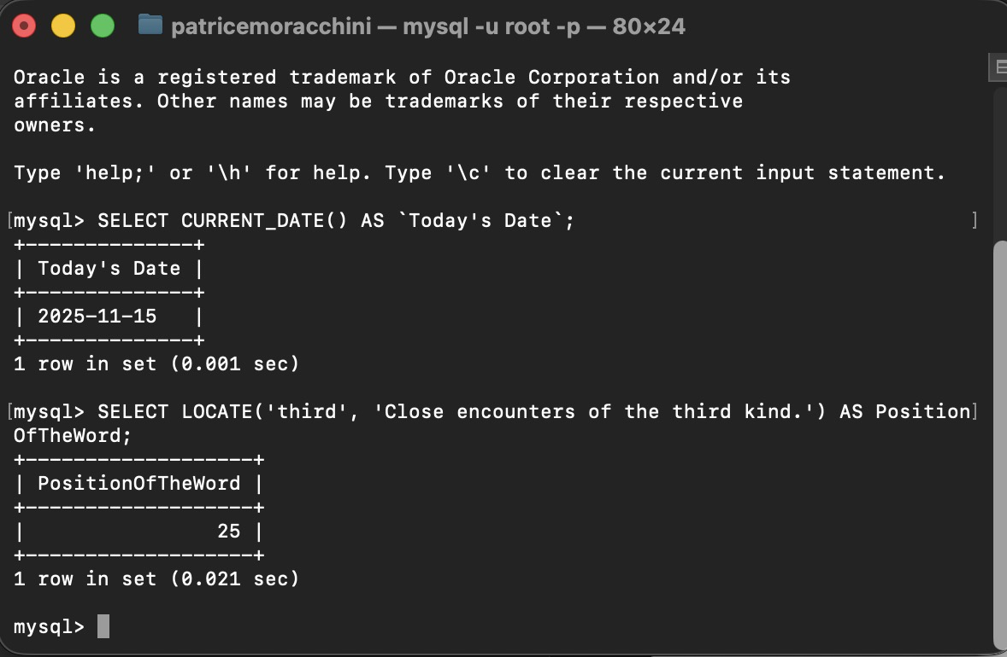
This function is useful when you need to verify the presence of a keyword or name in a list of words or a text. It also helps identify specific patterns or find and correct errors.

- CONCAT()
This function combines two or more strings.
The syntax will be:
CONCAT(expression1, expression2, expression3,...)
Example:
SELECT CONCAT('Close', ' ', 'Encounters', ' ', 'of', ' ', 'the', ' ', 'Third', ' ', 'Kind') AS FavoriteMovie; 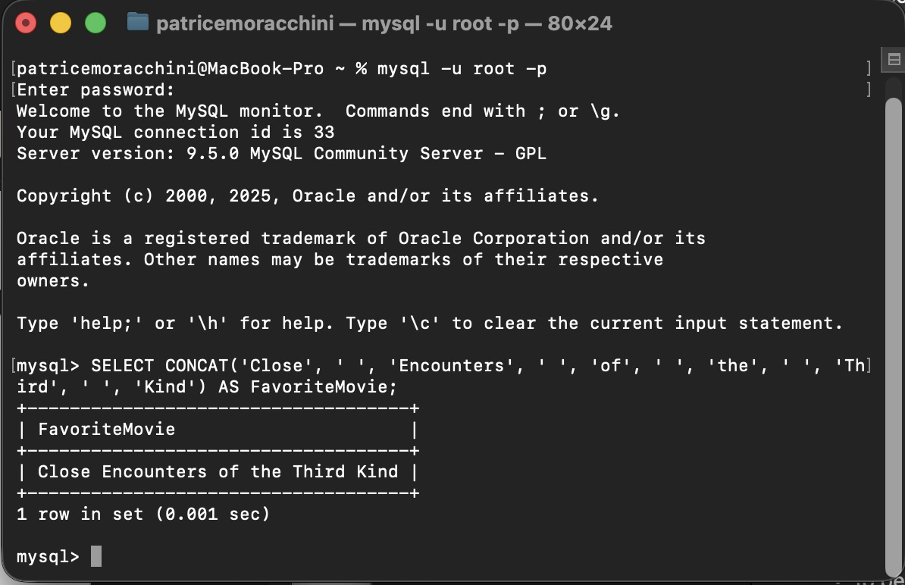
In Databases, CONCAT() is used to merge separate columns into a combined format. For example, if a report requires a customer’s name, it will be displayed as a full name, even if the first and last names are stored in different columns in the database.

- CURRENT_TIMESTAMP()
This function returns the date and time as a string (in the format: "YYYY-MM-DD HH-MM-SS") or as a numeric value (YYYYMMDDHHMMSS.uuuuuu), where the uuuuuu represents the six-digit microseconds.
The syntax will be CURRENT_TIMESTAMP() and + or – a number to change the time zone
Example:
SELECT CURRENT_TIMESTAMP() AS TheTimeOfMyLife;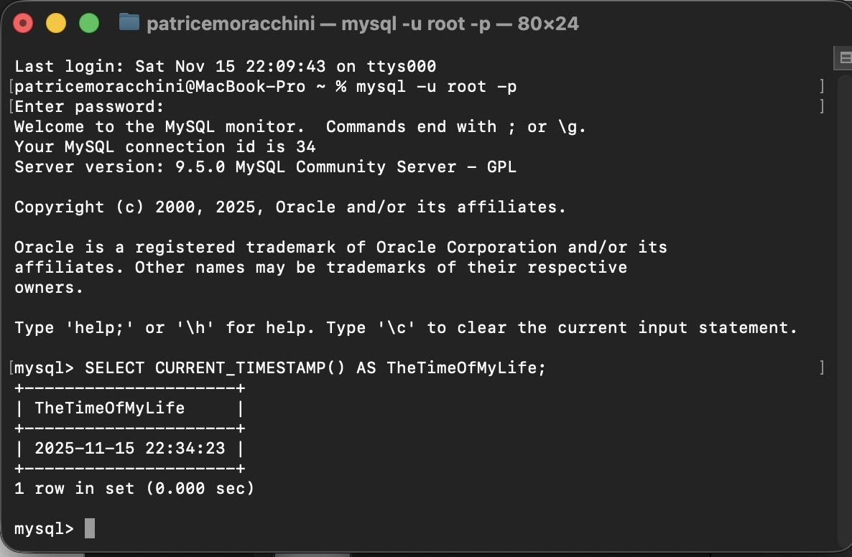

It is one of the most useful functions, as every time a record is added to a database, a timestamp is generated for tracking purposes. I can also filter data based on its timestamp, the time it was inserted or updated.

References
W3Schools. (n.d.). MySQL functions. W3Schools. https://www.w3schools.com/sql/sql_ref_mysql.asp

